Groups in Tableau

A group is a combination of all the similar dimensions members and measures that make higher level categories.

Create a group to combine related members in a field. For example:

English and Hindi might be combined into a group called language group, while biology and physics might be grouped as science majors.

Groups are useful for both correcting data errors.

Dimension

* US
* UK
* CA
* AUS
* SWE
* Other countries

Here are the custom groups I would like to have the ability to create

**Custom groups**

* US = United States
* UK + SWE + CA + AUS = International
* US + CA = America
* US + UK + SWE + CA + AUS + Other countries = Worldwide

**'Create Group'** only allows 1 dimension value per group i.e. dimension values such as US CANNOT be in the United States group and also in the America group.

**Calculated field'** In SQL I can do a case statement that would work fine but I can't use this in the calculated field.

**Create a Group:**

There are multiple ways to create a group. You can create a group from a field in the Data pane, or by selecting data in the view and then clicking the group icon.

Creating a group by selecting data in the view:

1. In the view, select one or more data points and then, on the tooltip that appears, click the group icon.

Note: you can also select the group icon on the toolbar at the top of the workspace.

If we have multiple levels of detail in the view, we must select a level to group the members. You can select to group all dimensions, or just one.

**Create a group from a field in the Data pane:**

1. In the Data pane, right-click a field and select Create>Group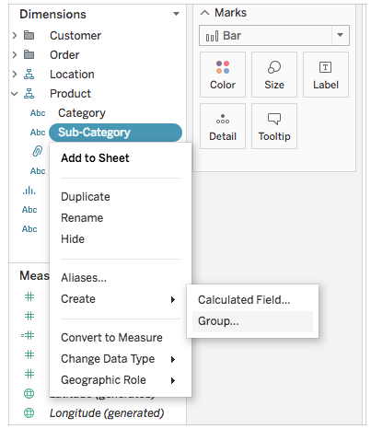
2. In the create group dialog box, select several members that you want to group,and then Group.

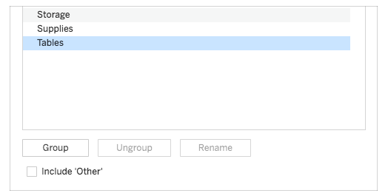

The selected members are combined into a single group. A default name is created using the combined member names.

To rename the group, select it in the list and click Rename.

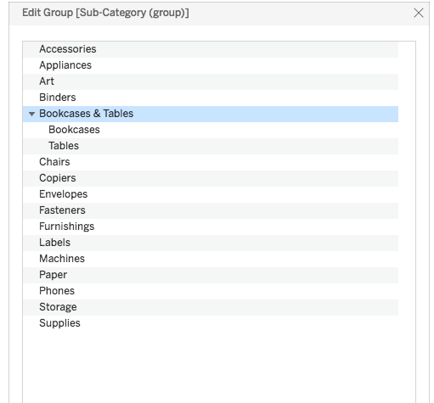

**Other Group:**

When we create groups in tableau, we have the option to group all remaining, or non-grouped members in other group.

**To include other group:**

1. In the Data pane, right-click the group field and select Edit Group.
2. In the Edit Group dialog box, select include ‘Other’.

Edit the Sub-Category group

* High performance
* Low performance

**Edit Group:**

After you have created a grouped field, you can add and remove members from the group, create new groups, change the default group names and change the name of the grouped field. You can make some changes directly in the view, and others through the edit group dialog box.

To add members to an existing group:

In the Data pane, right-click the group field, and then click edit Group.

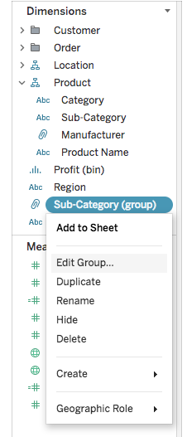

In the edit group dialog box, select one or more members and drag them into the group you want.

And then click ok.

**To remove members from an existing Group:**

* In the Data pane, right-click the group field, and then click edit group.
* In the edit group dialog box, select one or more members, and then click Ungroup.
* The members are removed from the current group, if we have another group, the members are added to it.
* And then click OK.

**Differences between Groups and Sets:**

* Sets are dynamic while Groups are not. When our data changes the set will update with it while this is not an option with groups.
* Sets offer greater flexibility as you can link them to a condition.
* You can group only within one dimension while with sets you can group across multiple dimensions.
* We can’t create calculation on the group.
* Grouping members in single dimension.

Example

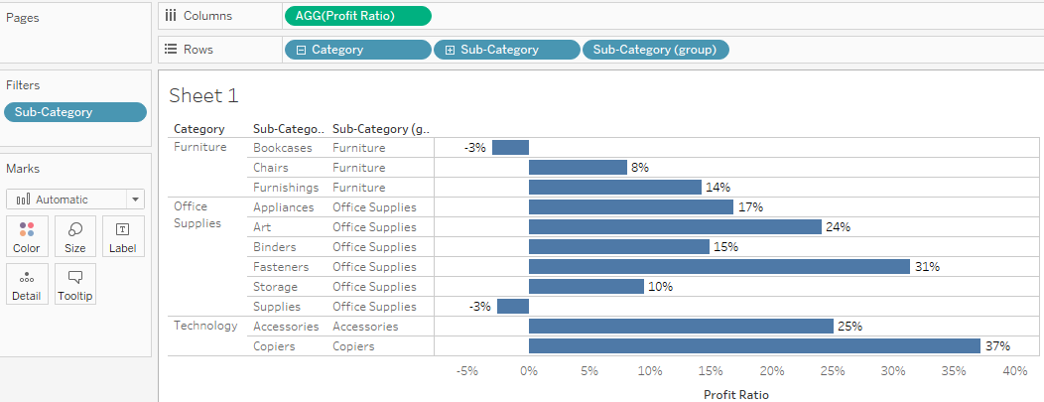

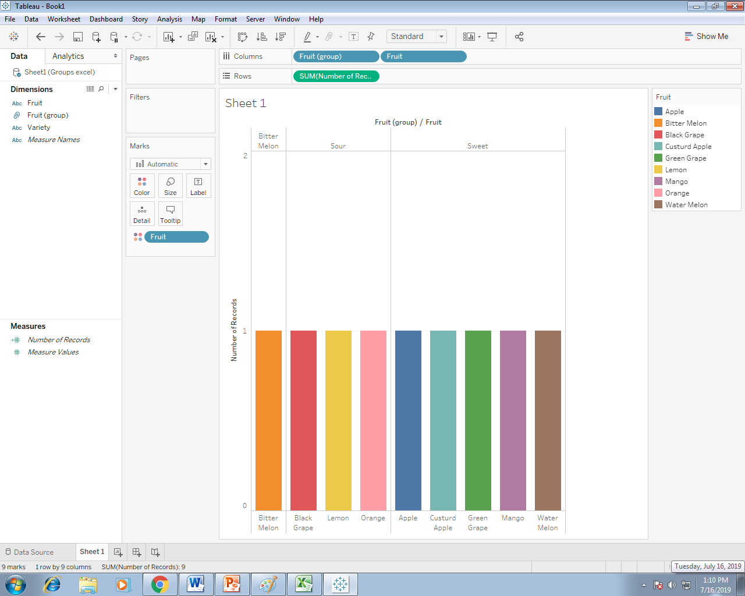

Even we can combine two groups into the single group using combine field option, but we are not having any combine group option.

If we combine two groups it will create a new field, not a new group.

Here we can create sub-category wise groups like, High medium and low performer based on profit and sales.

It is easily identified as low performer and high performer based on Coloring the group.

🡪 Coloring the Group

🡪Renaming the Group

🡪Edit the Group

🡪Removing the Group

🡪Add Members in the Group

🡪Combine the Two Groups

🡪Including Other Group

